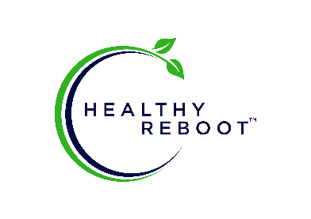
Chocolate Chip Blonde Brownies

These fudgy chocolate chip blondies are a breeze to make, chewy, chocolatey and just happen to be made with good for you ingredients too! A special gluten free, dairy free, paleo and vegan dessert your whole family will love. This does have sugar so is a recipe to use outside of the Healthy Reboot Program.

Author: Michele Rosen
Prep Time: 15 minutes
Cook Time: 22 minutes
Total Time: 37 minutes
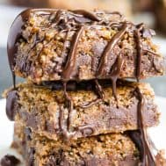

Ingredients
- 1/2 cup organic refined coconut oil solid but soft (refined has no coconut flavor)
- 2/3 cup organic coconut sugar
- 1 tsp pure vanilla extract
- 1/4 tsp sea salt
- 1 flax egg 1Tbsp ground flaxseed mixed with 2.5 Tbsp water - allow to sit for 10-15 mins
- 1 and 2/3 cups fine blanched almond flour
- 1/2 tsp baking soda
- 1/4 tsp sea salt
- 1 cup dark chocolate chunks or chips divided*

Instructions
- Prepare the flax egg as described above, begin to prepare the batter while waiting.
- Preheat your oven to 350 degrees F and line an 8 x 8" square metal baking dish with parchment paper.
- Combine almond flour, baking soda and salt in a medium bowl, set aside.
- Blend together coconut oil and coconut sugar using an electric hand mixer, then vanilla and sea salt until smooth. Beat in flax egg until smooth, then stir in dry ingredients. Beat with a wooden spoon for another minutes, then fold in 3/4 cup chocolate chips/chunks.
- Transfer to prepared baking dish and sprinkle remaining chocolate chips over the top. Bake in the preheated oven for 18-22 minutes until browning around the edges - it will look very soft but will firm up while cooling.
- Cool completely on a wire rack, and refrigerate prior to cutting. I prefer these stored in the refrigerator due to the coconut oil content - you can bring them back to room temp before serving. Makes 16 blondies.

